SMALL PINHOLE CAMERA
EIGHT-STEP BUILD INSTRUCTIONS

PROJECT / VERSION: SMALL PINHOLE CAMERA / v1.0 | BUILDER: ____________________ | DATE: ______________

  1 | STEP TITLE: GATHER MATERIALS
  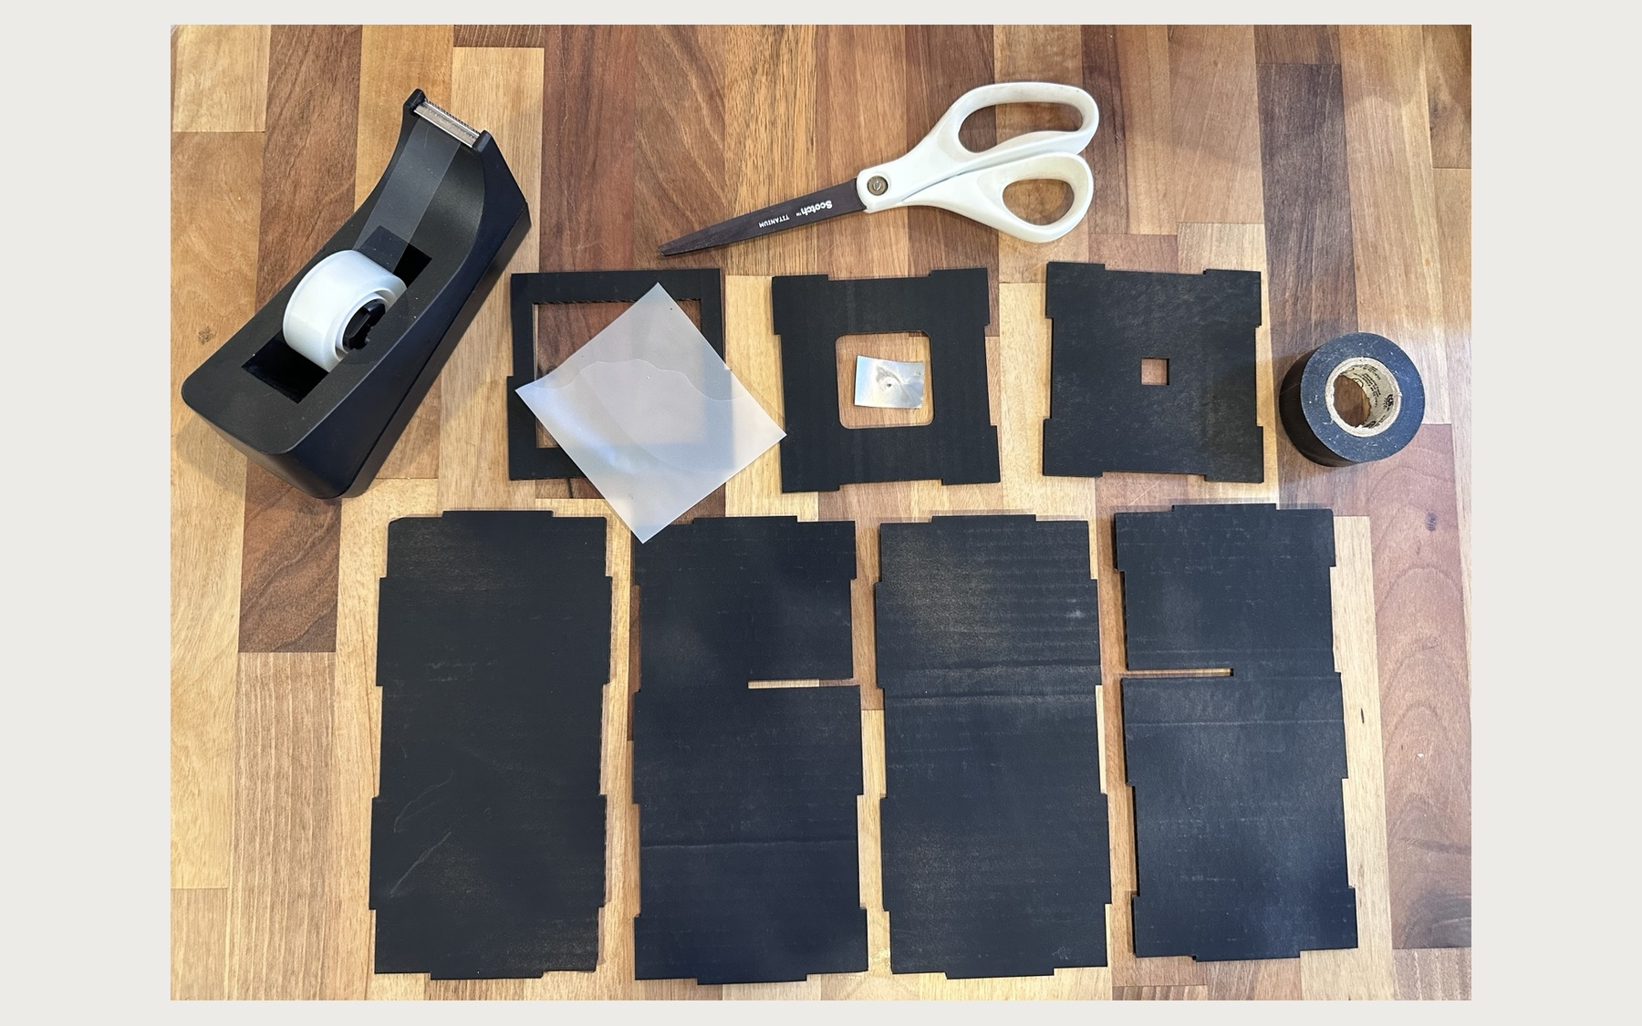
  WHAT TO DO: Gather all camera pieces, scissors, clear or transparent tape, black tape, the translucent screen material, and the pinhole insert.
  DETAILS: Lay everything out as shown and confirm all parts are present before starting.
  2 | STEP TITLE: PREPARE THE SCREEN
  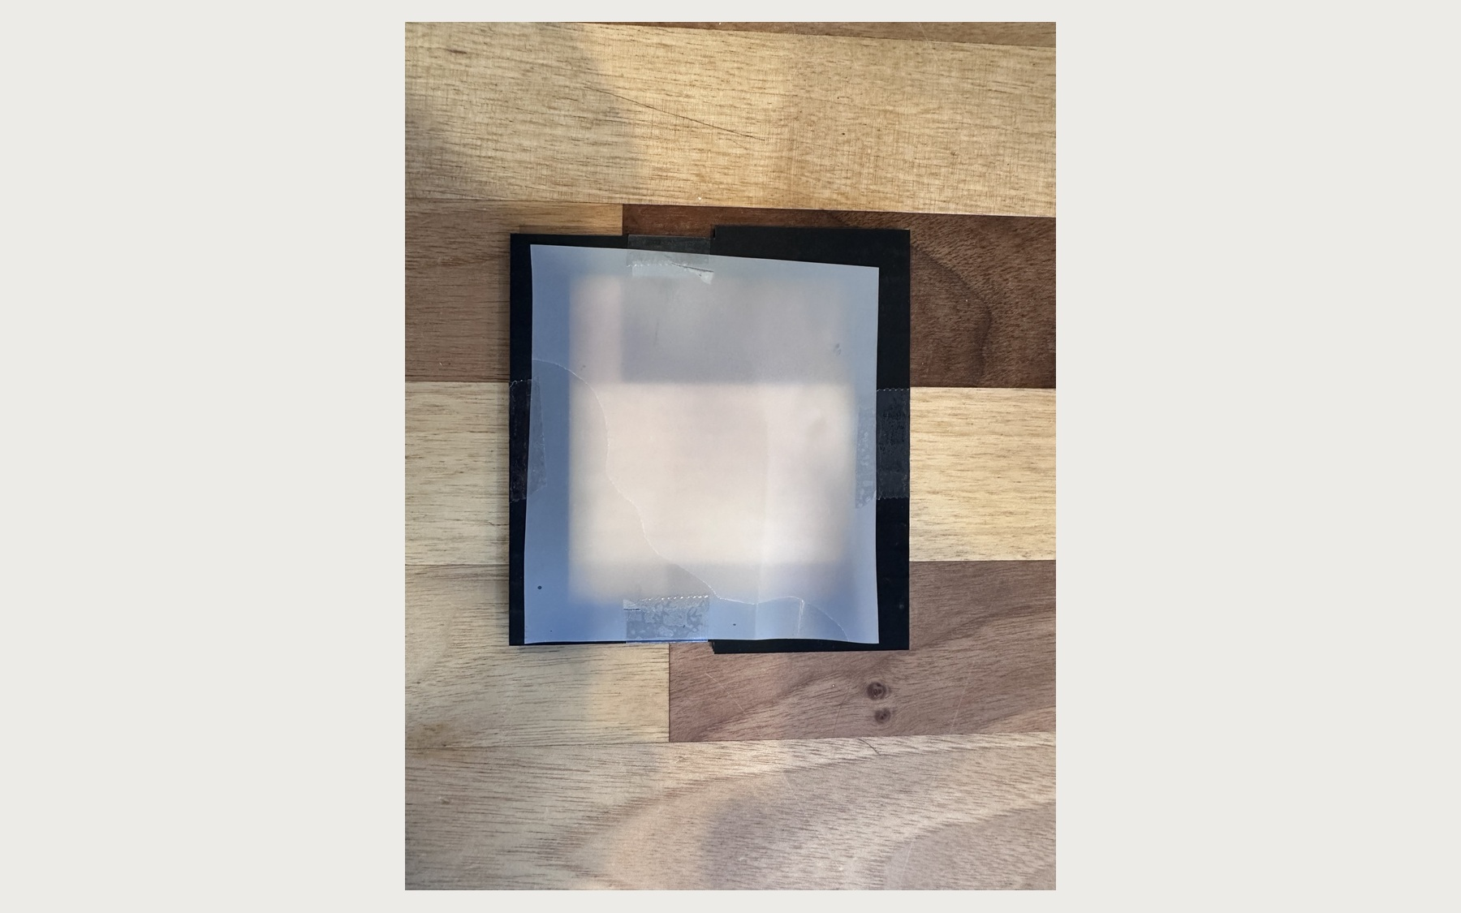
  WHAT TO DO: Tear off 12 pieces of transparent tape. Use two pieces to attach tissue paper, tracing paper, or scrim material to the black side of the frame.
  DETAILS: Keep the material flat and cover the entire opening. Trim any excess if needed. Use more tape if needed.
  3 | STEP TITLE: FORM THE BODY
  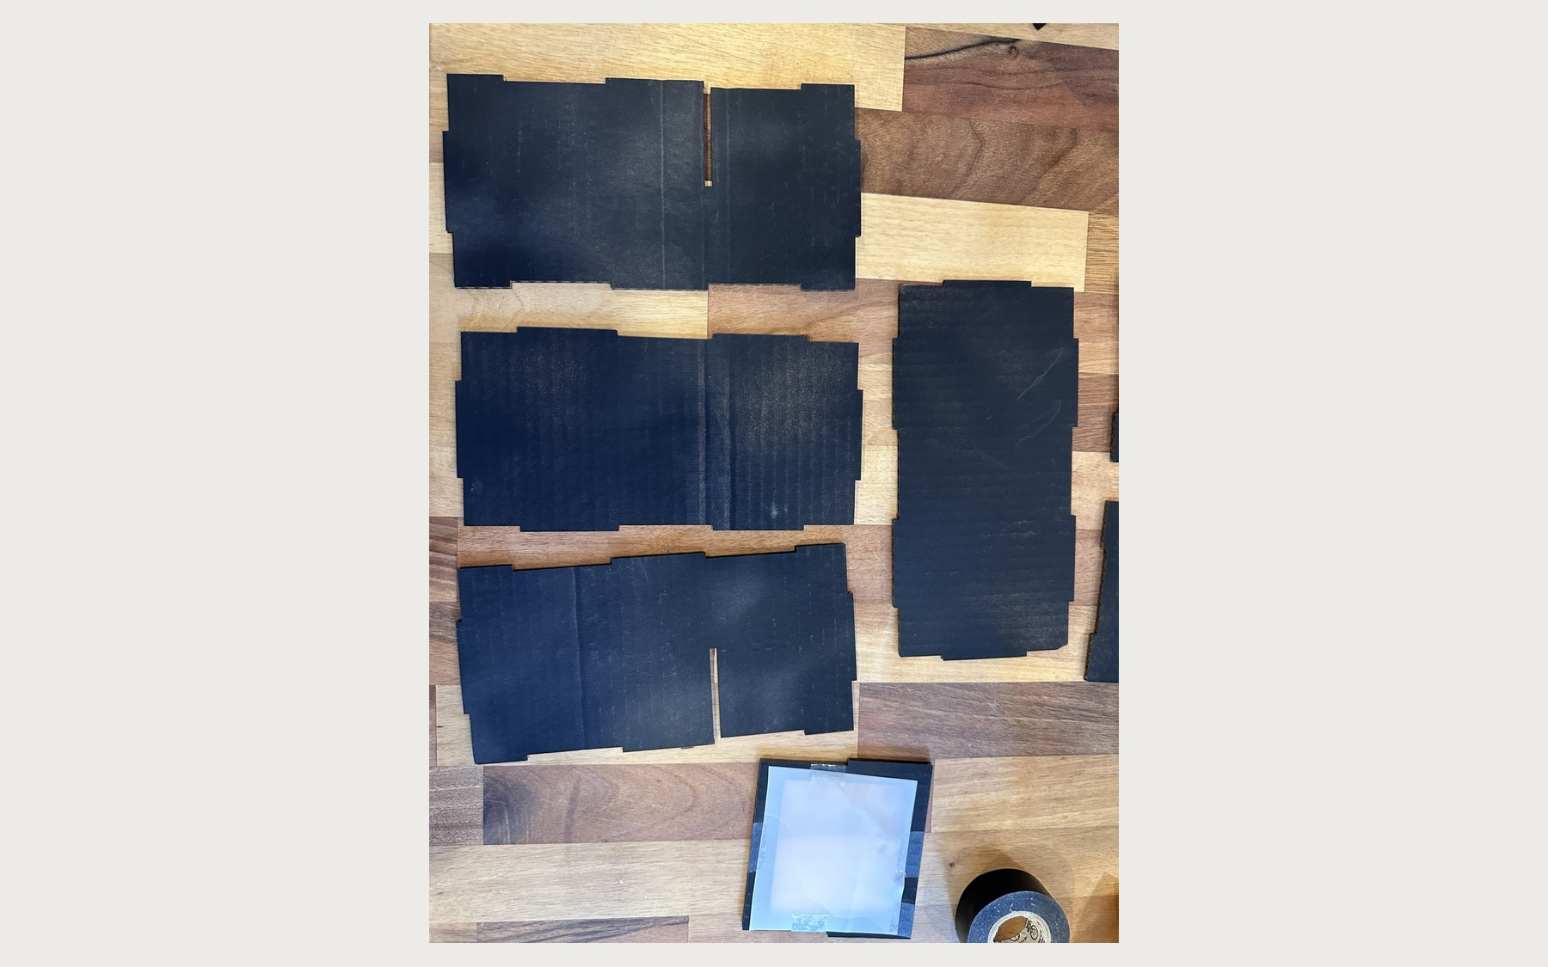
  WHAT TO DO: Lay out the long body pieces to create a bottom and two side walls. Fold the bottom and sides together, then use clear tape to hold the seams. This is only a temporary hold.
  DETAILS: Keep the black surfaces facing inward and align the tabs and edges before taping.
  4 | STEP TITLE: ADD ENDS + SCREEN
  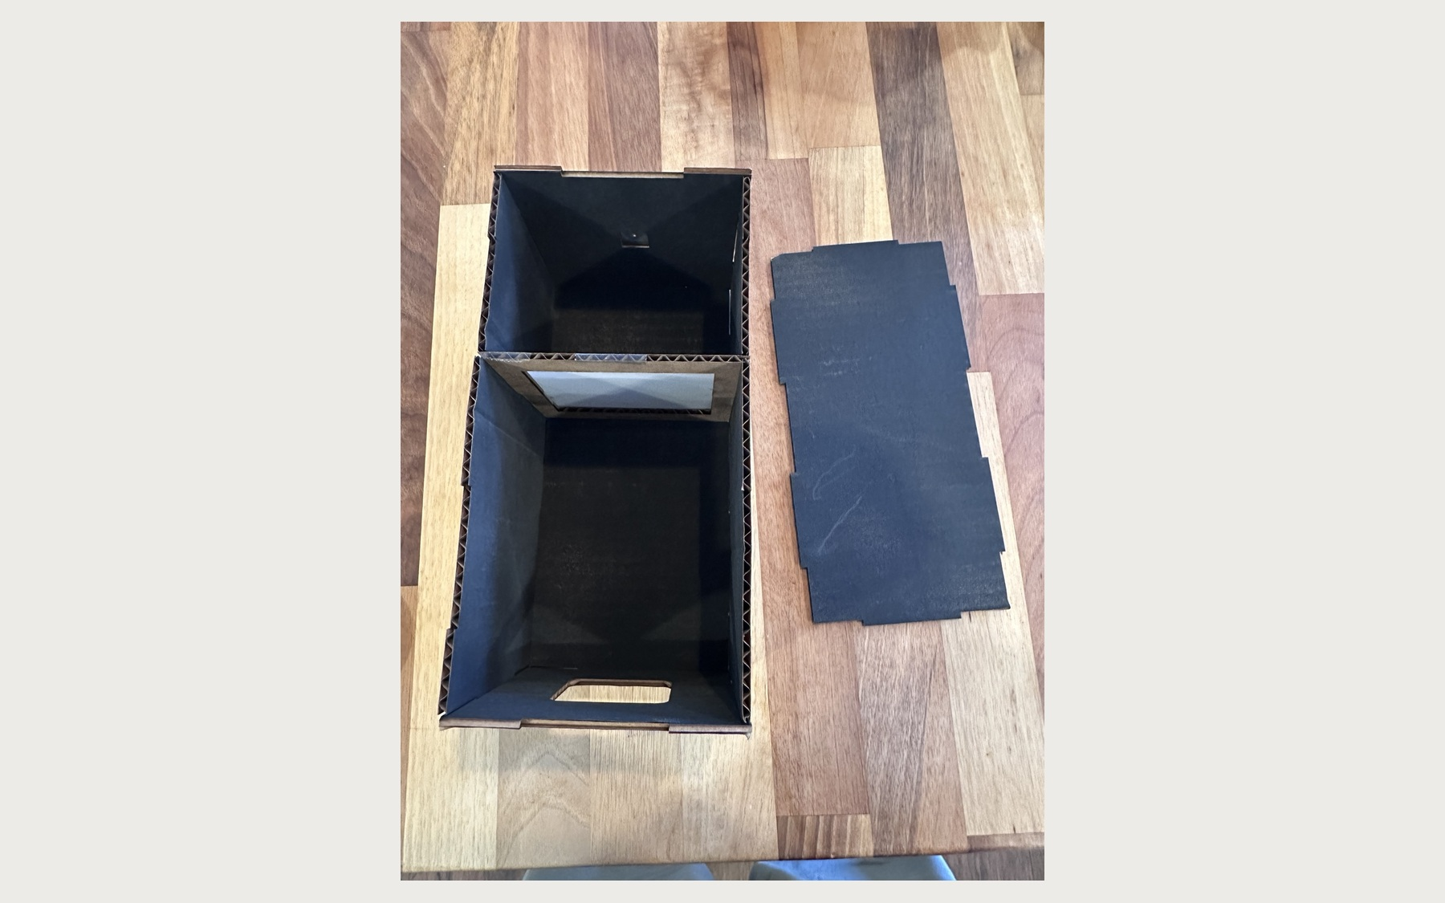
  WHAT TO DO: Tape the end with the large square opening to the larger section. Tape the end with the small square opening to the smaller section, then secure the screen frame inside with its black side facing the smaller section.
  DETAILS: Use clear tape. The small square opening is where the pinhole will be placed.

SMALL PINHOLE CAMERA
EIGHT-STEP BUILD INSTRUCTIONS

PROJECT / VERSION: SMALL PINHOLE CAMERA / v1.0 | BUILDER: ____________________ | DATE: ______________

  5 | STEP TITLE: CLOSE BOX + ADD PINHOLE
  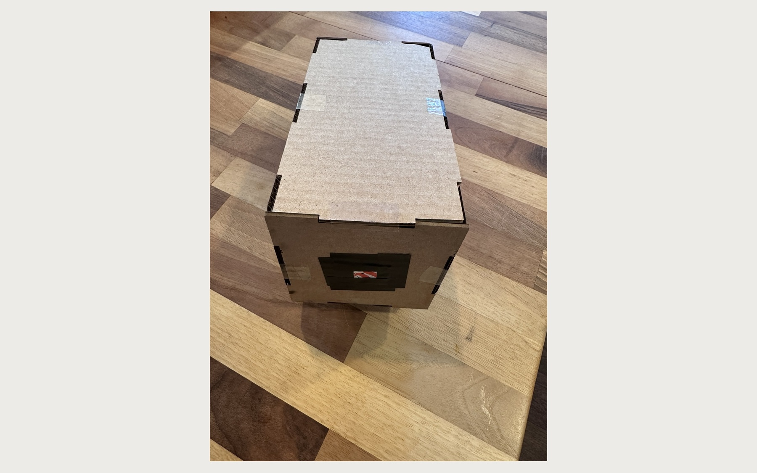
  WHAT TO DO: Use clear tape to attach the top panel and close the box. Center the pinhole insert over the small square opening and secure it with black tape.
  DETAILS: Do not cover the tiny pinhole in the center.
  6 | STEP TITLE: WRAP THE CENTER SEAM
  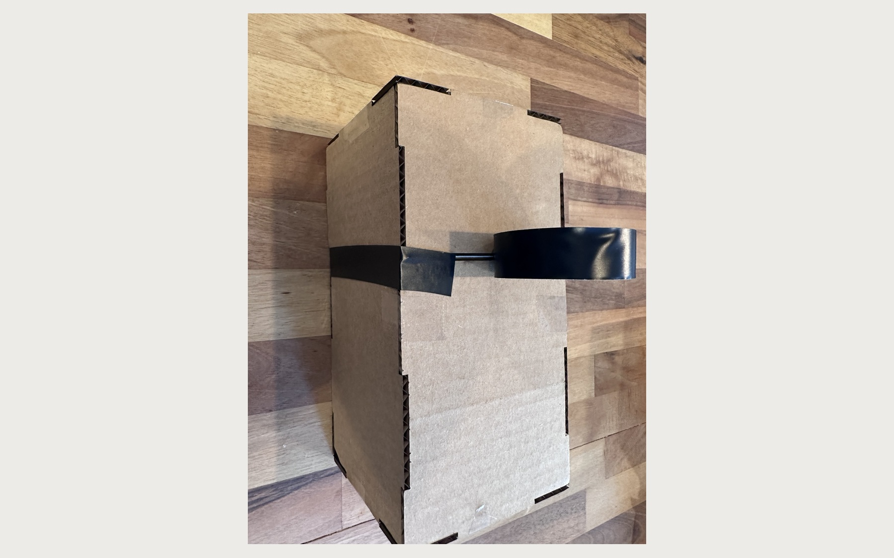
  WHAT TO DO: Wrap black tape all the way around the box at the screen-frame divider. Cover the seam and any gaps around the full camera.
  DETAILS: Overlap the tape slightly and press it firmly against every corner.
  7 | STEP TITLE: TAPE THE LONG EDGES
  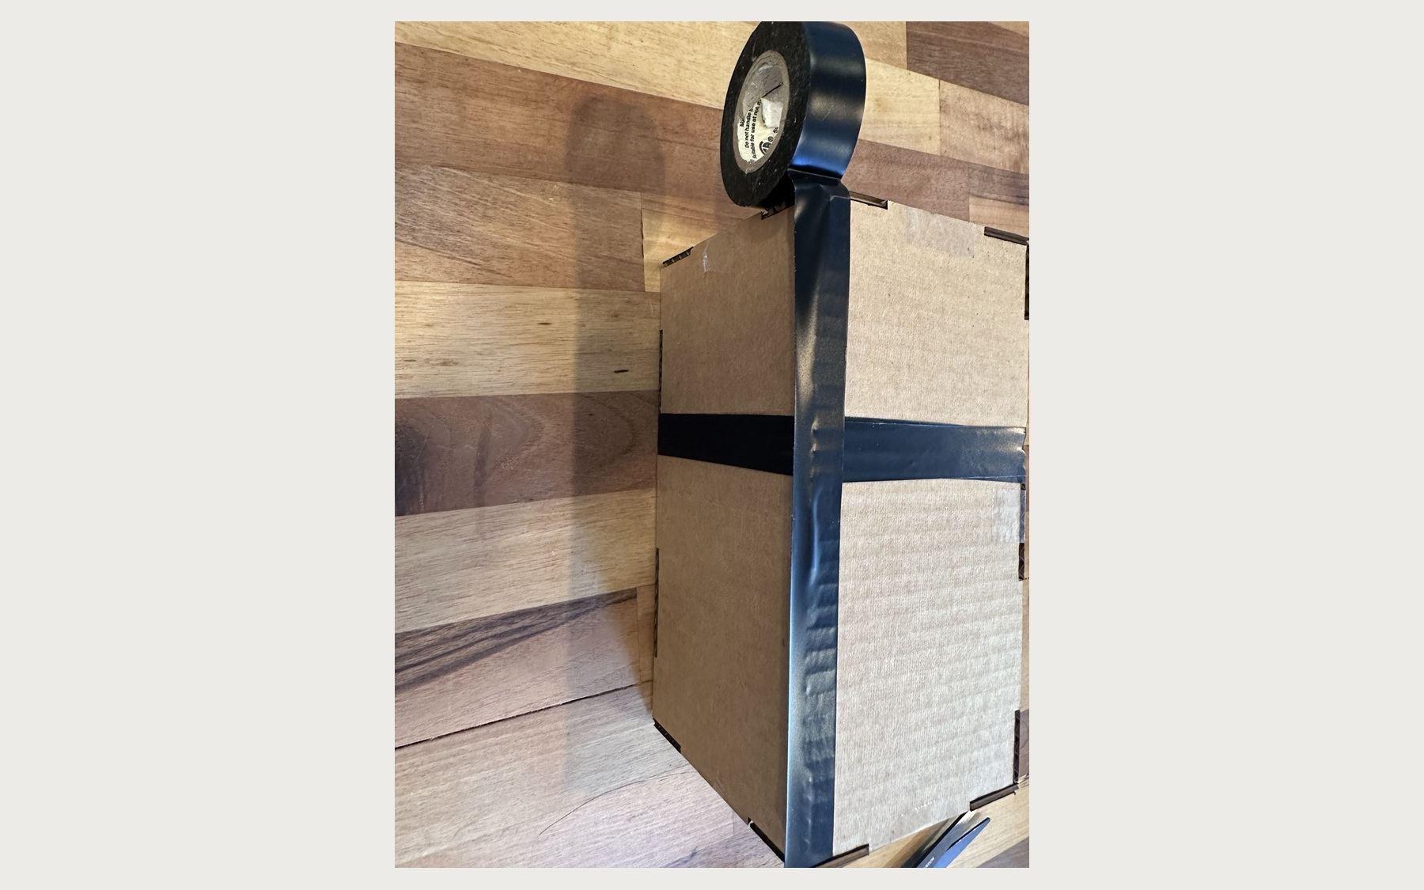
  WHAT TO DO: Run black tape along the long outer edges and corner seams. Fold the tape over each edge so both adjoining panels are sealed.
  DETAILS: Press out wrinkles and cover any exposed cardboard gaps. Try stretching it it will naturally curl over the edge.
  8 | STEP TITLE: SEAL EVERY EDGE
  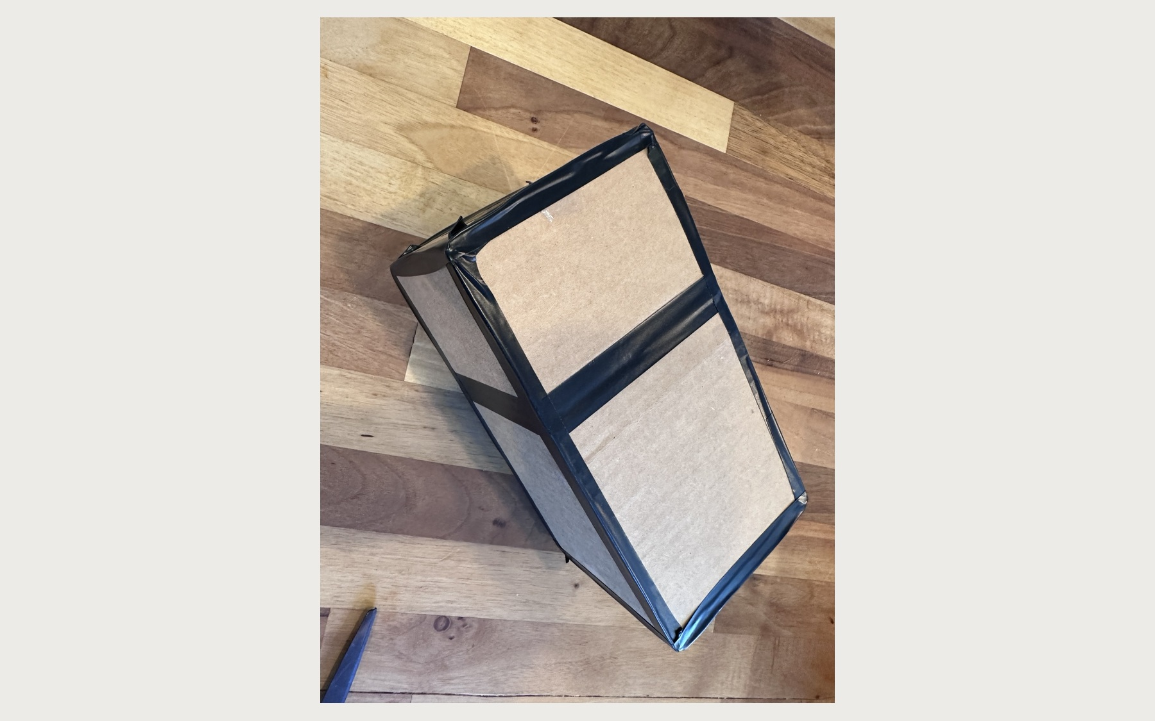
  WHAT TO DO: Finish covering all remaining seams and exposed edges with black tape. Check the entire camera for openings where stray light might enter.
  DETAILS: The camera is complete when every seam is sealed except the large viewing opening and the tiny pinhole.

